**EEE 587 Optimal Control – HW 1**

Siddharth Jain 1226137070

**Question 1. Forward Enumeration**

1. Route 1 – a – d – e – h

Cost – 1 + 2 + 8 = 11

Optimal Route – E – E – E

1. Route 2 – a – b – c – f – g – h

Cost – 1 + 1 + 1 + 13 + 2= 18

Optimal Route – S – E – E – E – N

1. Route 3 – a – d – e – f – g – h

Cost – 1 + 2 + 2 + 13 + 2 = 20

Optimal Route – E – E – S – E – N

1. Route 4 – a – b – c – d – e – h

Cost – 1 + 1 + 2 + 2 + 8 = 14

Optimal Route – S – E – N – E – E

1. Route 5 – a – b – c – d – e – f – g – h

Cost – 1 + 1 + 2 + 2 + 2 + 13 + 2 = 23

Optimal Route – S – E – N – E – S – E – N

Based on the minimum cost – Route 1 is selected with the cost of 11 (highlighted in green)

Route 1 – a – d – e – h

Optimal Route is therefore – E – E – E

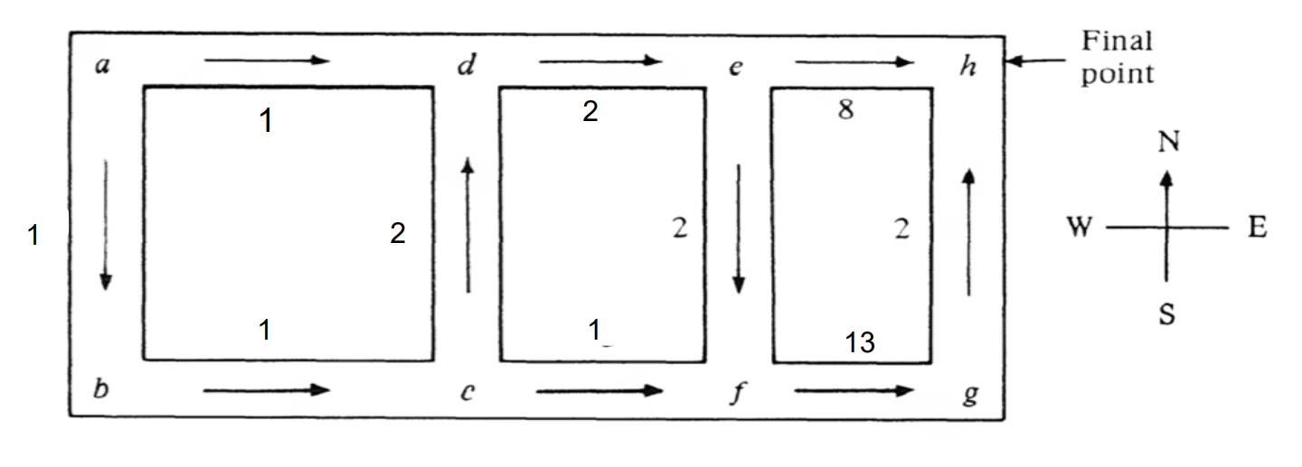

**Question 2. Principal of Optimality**

Applying the principal of optimalitym we start from the last state g and move backwards to the initial state a. In each state, the most optimal path is selected.

|  |  |  |  |  |  |
| --- | --- | --- | --- | --- | --- |
| Current Intersection | Heading | Next Intersection | Min. cost to reach from a to h via xi | Min. cost to reach from a to h | Optimal Heading |
| g | N | h | 2 + 0 = 2 | 2 | N |
| f | E | g | 13 + 2 = 15 | 15 | E |
| e | E | h | 8 + 0 = 8 | 8 | E |
| S | f | 2 + 15 = 17 |
| d | E | e | 2 + 8 = 10 | 10 | E |
| c | N | d | 2 + 10 = 12 | 12 | N |
| E | f | 1 + 15 = 16 |
| b | E | c | 1 + 12 = 13 | 13 | E |
| a | E | d | 1 + 10 = 11 | 11 | E |
| S | b | 1 + 13 = 14 |

As it can be seen, there is no optimal route if we start from G

Optimal path when we start from E



Optimal Route using Principal of Optimality – a – d – e – h (highlighted in green)

Route – E – E – E

Therefore the optimal action at state a is East which will take it to state d, then again East to take it to state e and finally East to take it to the destination h.

Hence total cost is 11.

Which is the same as the route found using forward enumeration.